Yr 12 General Integrated Science
TASK 4 – Effect of urban sprawl on biodiversity

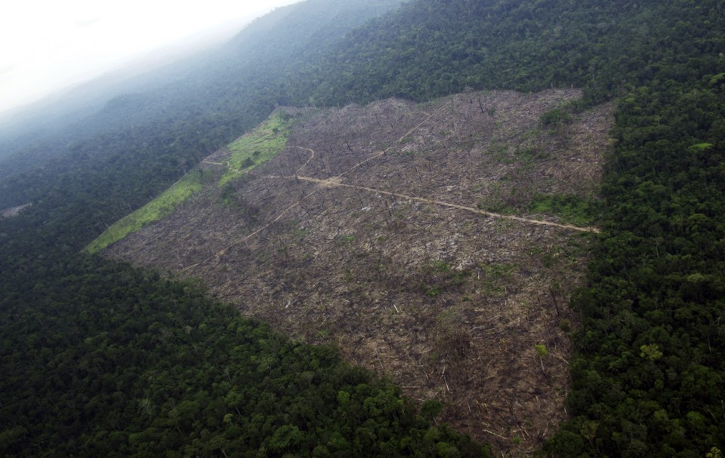
The Amazon forest in the Amazon basin is the largest and most dense rainforest in the world. It has an area of over 5000 000 km². It is estimated 1.6 billion people worldwide rely on forests for their livelihoods, including 60 million indigenous people who depend on forests for their subsistence. Forests play an important role in our survival on earth. They purify the air, improve water quality, prevent soil erosion, provide organisms with food, wood products and medicines, and are a sanctuary for many animals including endangered wildlife.
The land on the edge of the Amazon is constantly being cleared to make room for cattle, pastures and food crops. This forces the subsistence farmers from their land. The Amazon forest is also logged to provide timber for buildings and furniture and woodchips for making paper. Scientists estimate up to 20% of global carbon emissions come from deforestation; that is greater than emissions from every car, truck and plane on the planet combined.

Your task is to explore how urban sprawl in South America has affected the Amazon rainforest. Explain how overpopulation has impacted on the rainforest. Explain how each of the human practices is impacting on the Amazon ecosystem.


The Rainforest Action Network estimates that rainforests around the world are being cleared at a rate of 10 000 m² every second.

Due date: Friday Week 8 Term 2

